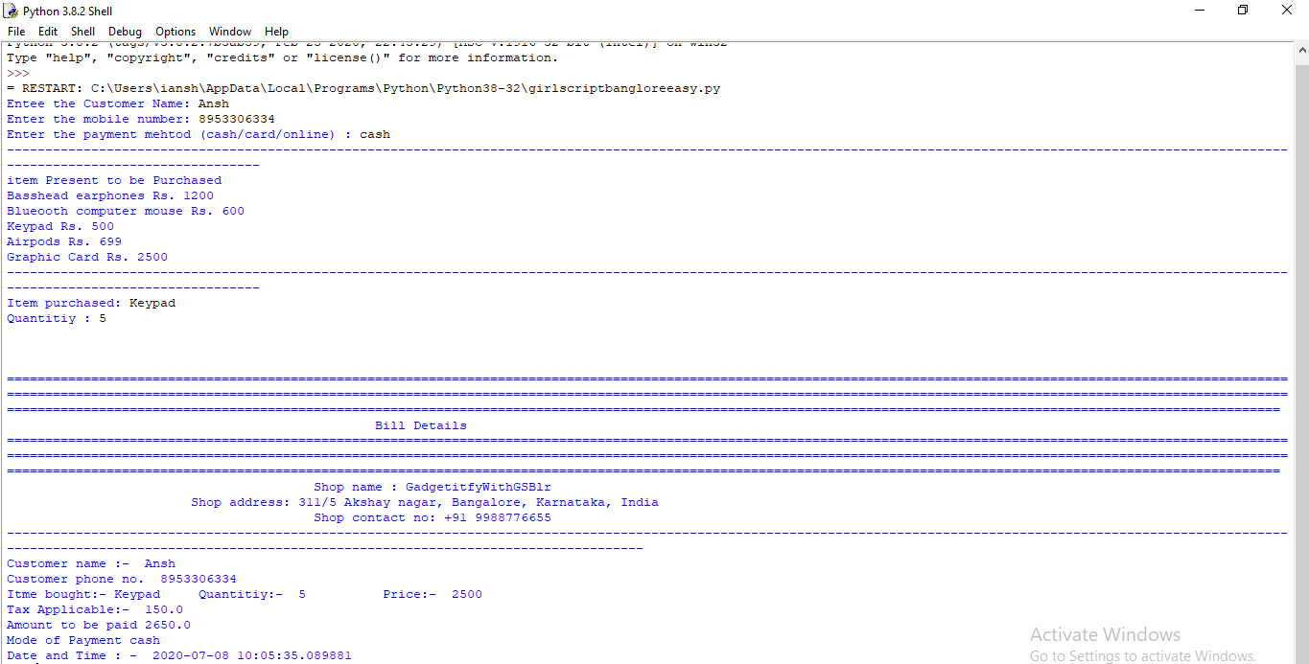

The Whole Code is written in Python 3.8.2 in python IDE only.

1. Here I took the help of dictionary concept to store the item list present in the shop. I Stored the . items with their amount as key:value pair in the dictionary.
2. First I stored 5 items in dictionary and stored the list in a variable by name “shoplist”.
3. Used a while loop if the user may want to deal with more then one customer , then the program can be modified easily just by removing the break command at the end the code.
4. Took the input from the user about the customer name and all. The presented them with the list of items present with simple use for loop
5. Calculation of tax is done with 6% tax on total amount i.e (6/100)\*total amount
6. The line with “\n\n” is used only to change lines nothing else.
7. Then the next three line is used for printing the details of the shop with the basic print statement.
8. Then all the details of the customer is printed along with the Item he/she bought from the store.
9. For getting the system time I imported date, time,datetime from a module datetime, and now uis used for formatted time with YYYY-MM-DD HH:MIN:SEC.